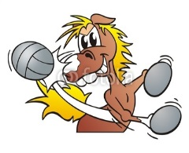2016

MUSTANG GRASS VOLLEYBALL

QUADS LEAGUE

**Back by popular demand, the Clifton Recreation Department will be bringing back the Grass Volleyball League this year. This is an adult quads league (age 18+) that will include 10 weeks of play (8 weeks of round robin play and 2 weeks of playoffs). Prior to the 10 week season, there will be 2 weeks of open play, free of charge, to allow teams an opportunity to get some play time together and/or to aid teams looking for additional players. Depending on the number of teams participating, we will provide different divisions of play.**

**League Director – Michael Campbell**

**Site**

**Robin Hood Park**

**Priscilla Street & Standish Drive – Clifton, New Jersey 07013**

**Dates**

**TUESDAYS**

**June 7th & June 14th Open Play (no charge – open to teams & individuals)**

**June 21st – August 9th – Round Robin League Play**

**August 16th & August 23rd Playoffs**

**Time**

**6:00 p.m. – 8:30 p.m.**

**Fee**

**$100.00 per team if registered by June 8th**

**$125.00 per team if registering after June 8th**

**Contact the Recreation Department, at (973) 470-5956 or via email to doliver@cliftonnj.org, to register your team. Check out our 2016 Grass Volleyball Tournament Series on our website at www.cliftonrec.com**

**In the event of inclement weather call the weather hotline (973) 470-5680.**

**Games will be cancelled at 4:00 p.m.**

MC900001392[1]